**Pfsense firewall setup and remote desktop**

Derek Liu

Cybersecurity

Period 5

Lab #5

**PFSense SOHO Setup and Remote Desktop***Derek Liu*

Purpose

To setup and configure a pfSense firewall on a SOHO network and allow remote desktop access from the WAN side.

Background Information

The pfSense firewall is the free and open-source firewall and router. The software is distributed based on FreeBSD and is installed on a physical computer of a virtual machine to be used as a dedicated firewall/firewall. It can be easily configured through a web interface.

The management interface of the system is based in on the PHP language which means that the UNIX command line doesn’t need to be used. In terms of support, the developer and user community can provide support and assistance since it is open source.

Other than acting as a firewall by filtering data packets that pass through the network, a pfSense also supports NAT, load balancing, VPNs, DHCP, and others. In this lab we will mainly focus on configuring NAT and DHCP.

In this lab, the pfSense will be configured to receive an IP address from the WAN side as DHCP client and assign IP addresses on the LAN side as a DHCP server. After assigning addresses to the network card, the web interface can be accessed. In this lab, NAT will be configured to allow a remote desktop connection from the WAN side.

Remote desktop allows for a user to remotely control another computer’s desktop through a propriety protocol. In this case we will use Microsoft’s remote desktop software on a Windows device. Remote desktop by itself is not a secure setup and requires additional security measures in order to prevent it from being used maliciously. It can be useful in the case that an administrator needs to access a desktop but is unable to gain physical access to the device.

Configurations

1. Plug in a USB that will be used to contain the image of PFSense into a computer. Download RUFUS online

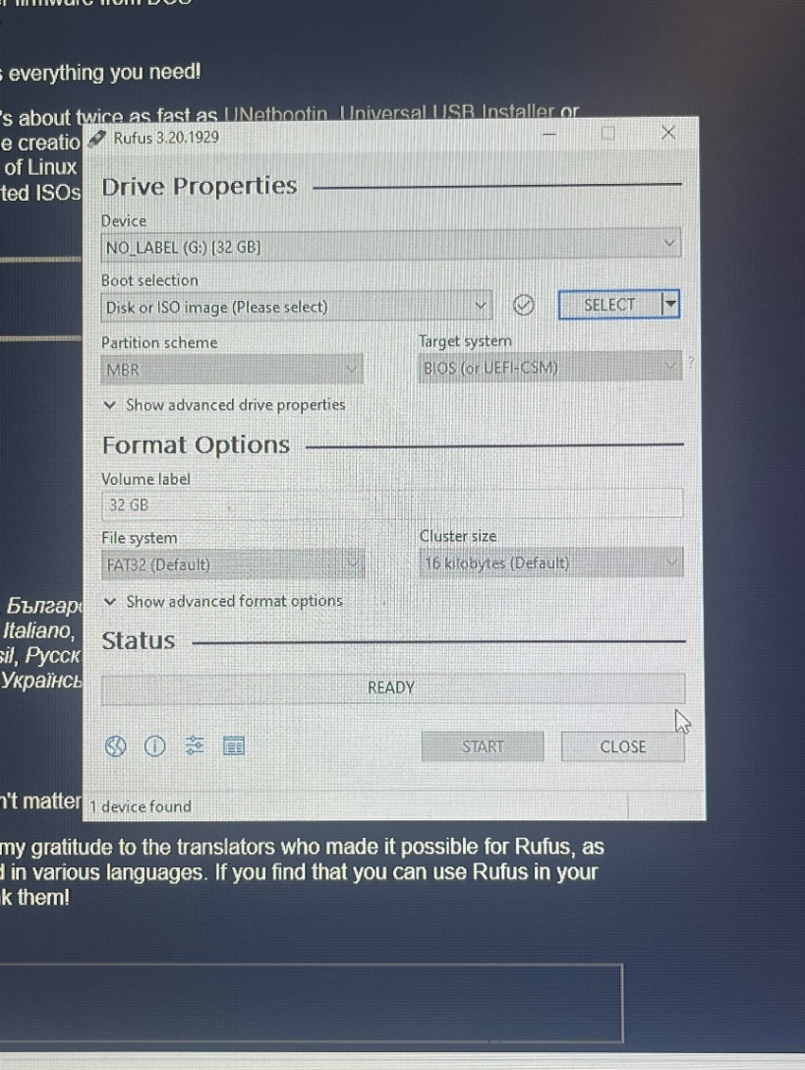

1. Download PFSense online

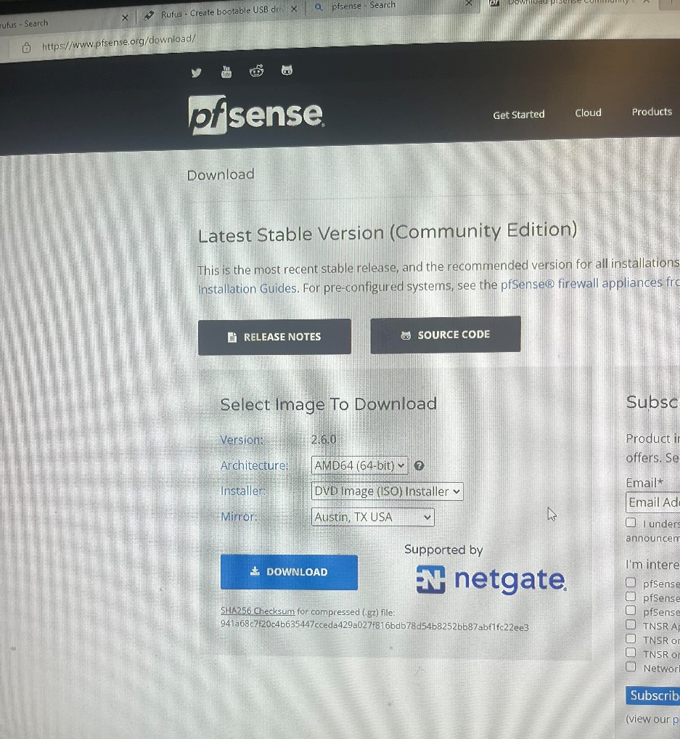

1. Unzip the PFSense ISO file that is downloaded

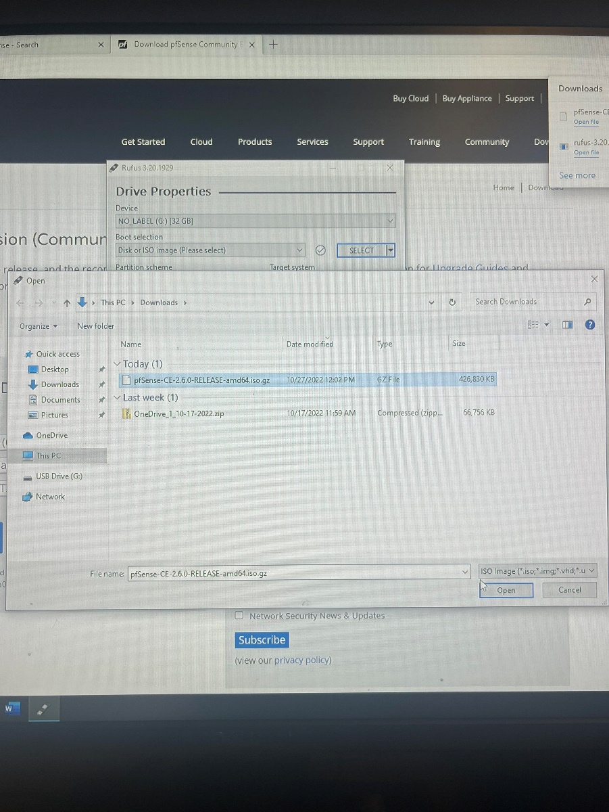

1. Select the ISO that was unzipped in RUFUS and reformat the USB. Plug in the USB into the device that will be used as the PFSense firewall (A laptop was used in this lab). Connect an ethernet cable from the PFSense to the WAN and another to the LAN.
2. Turn on the device and image it.
3. This should be the screen reached:

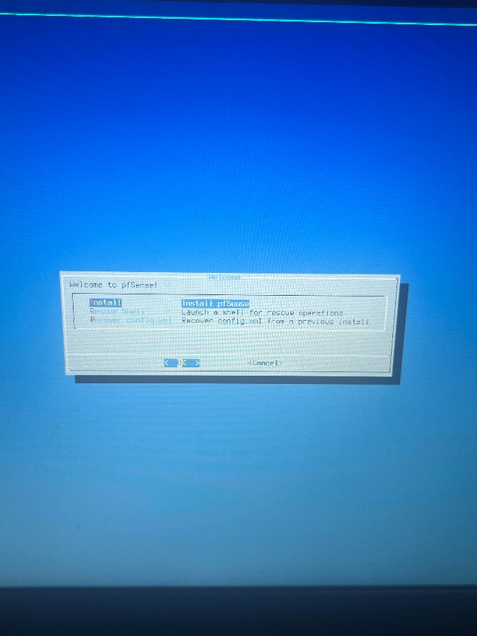

Select install.

1. Continue with a default keyboard, select Auto (UFS) UEFI, select no, select reboot.
2. This should be the result:

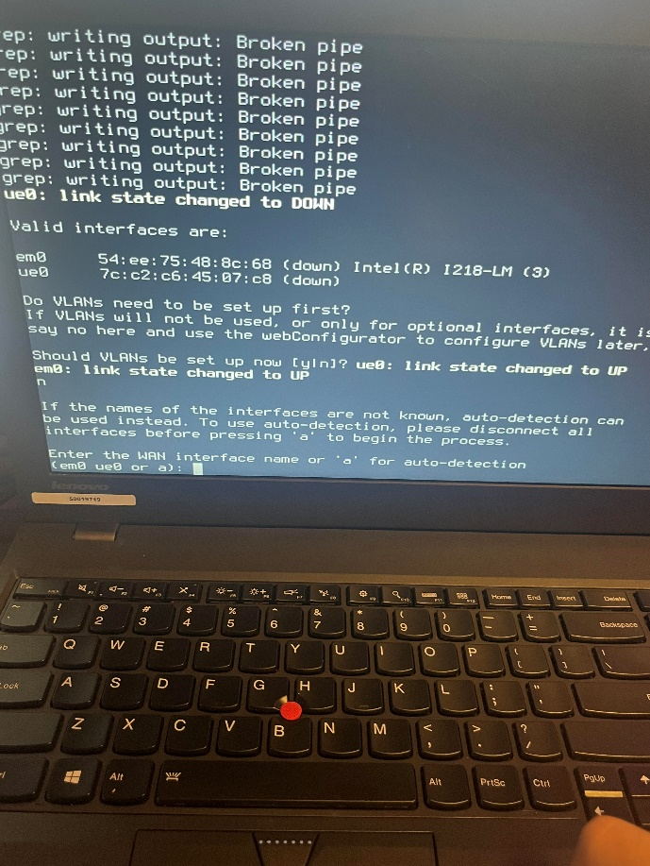

1. Select “no” for setting up VLANS
2. Assign the WAN and LAN interfaces accordingly.
3. Configure IP addresses for the WAN and LAN interfaces.
4. Got to <https://192.168.1.1>

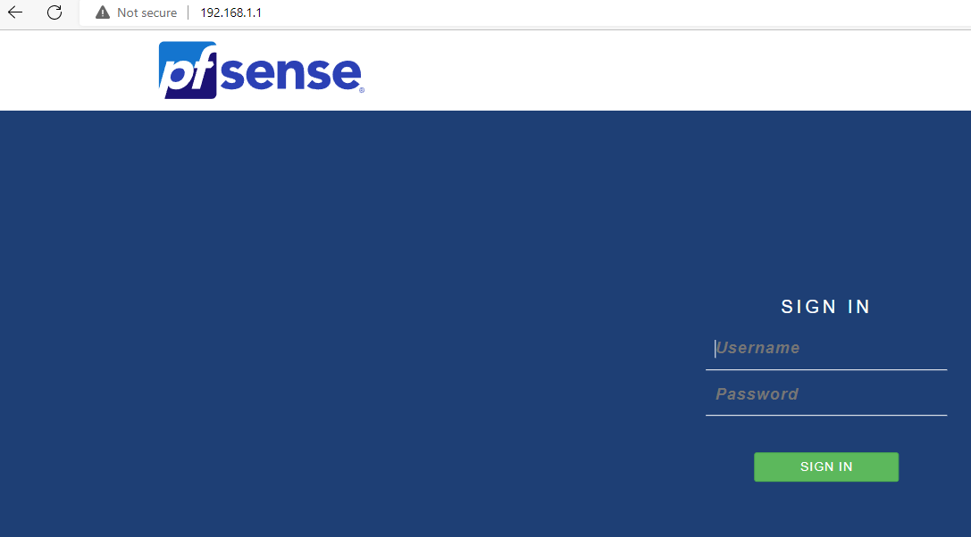

Default username: admin

Default password: pfsense

1. Go to firewall -> NAT

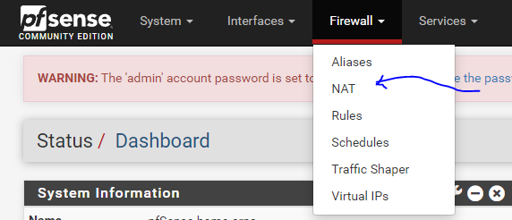

1. For interface port range use 3389. Target IP should be the ip address of PC. Target port: 3389. Save

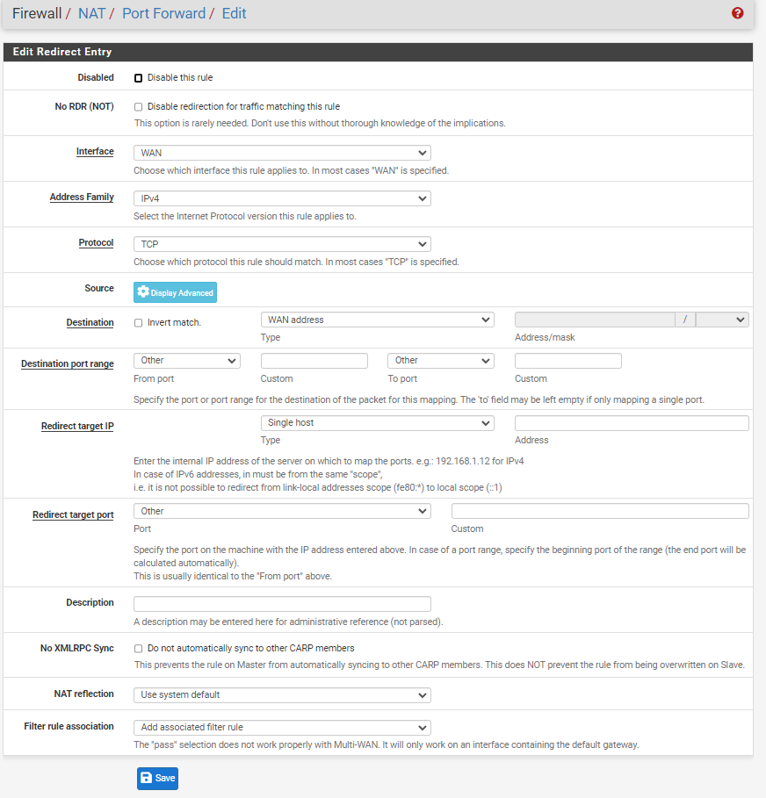

1. Enable remote desktop through settings and search for remote desktop.
2. Type in the address of the device you want to connect to

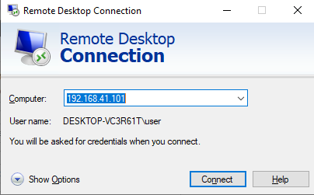

1. Click connect. Type in the username and password of the device you wish to connect to.

Problems

When setting up the pfSense, a problem came from experimenting with where it should be placed within a SOHO network and how to put the pfSense image into the device. Originally the device was booting into legacy so that was fixed by configuring the BIOs to boot into UEFI. Most problems arose from configuring the pfSense. When assign IP addresses to interfaces, the WAN side had trouble receiving an address through DHCP. This was fixed by detaching and reattaching the ethernet cable. Initially, when trying to access the web interface, it showed an error message of a bad gateway. This problem was solved by completely redoing the lab with the exact same configurations since we were unsure of the root cause of this problem. It worked the second time through.

Conclusion

In this lab, we set up a pfSense in a SOHO environment. We configured interfaces using DHCP for both the WAN and LAN side in order to access the web interface. Through the web interface we set up remote access to allow a connection from the WAN side to the LAN side. The majority of the obstacles in the lab appeared during the initial set up of the pfSense.